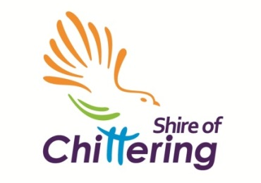 | Shire of Chittering  6177 Great Northern Highway  (PO Box 70) BINDOON WA 6502  E: chatter@chittering.wa.gov.au  T: 9576 4600 / F: 9576 1250  W: www.chittering.wa.gov.au
Chittering Business List
The Shire of Chittering are maintaining a list of the businesses approved to operate within our community.

This list gives a big picture of the resources that we have in our Shire. The database list will be used for business promotion and networking purposes, your personal details will not be passed onto any third parties.

Our FREE Online Business Directory is a self-managed system so that proactive business-owners can update their listing with weekly specials and other offers. There is a direct link to your website if you would prefer the listing to be ‘static’. Visit www.chittering.wa.gov.au and click “Discover” “Chittering Business List”.

The SHOP Chittering Support LOCAL campaign will focus on driving traffic to the new Business Directory, to put potential customers in touch with you.
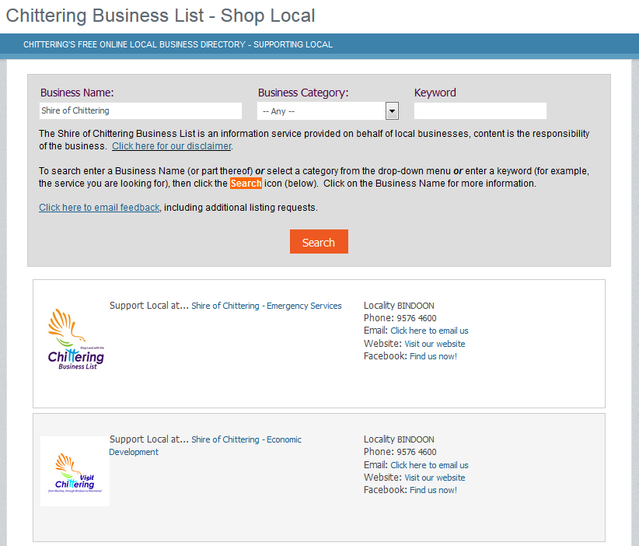

Please return your completed form (see reverse)
via mail / email / fax / in person

Chittering Business List
Expression of Interest
Business Name:
Contact Name:
Postal Address
Telephone:
Fax:
Email:
Website:
Business Type:
 | For example; B&B, café, commercial, home business, home office, restaurant, retail, rural home business, rural pursuit, shop, winery…
Contact Name:
Shire Assessment #:  (as per Rates Notice) | A |  | For business or home, for records, not for publication.
Planning Approval #: (if applicable)
 | For verification only, not for publication. Please note, not all Business Types require Shire Approval. If you are unsure whether your business needs approval please simply write “unknown” or contact the Shire’s Development Services Department for further assistance. If you know that your business does not require formal approval please write “exempt”.
Accommodation: |  |  | ‘Lodging house’ approvals are issued on an annual basis.
Food: |  |  | Food businesses are rated High, Low or Medium risk.
Service 1:
Service 2:
Service 3:
Service 4:
Facebook:
Other comments:
All Shire information is available in alternative formats on request
Office Use Only : 08/02/0004 & A# file
Received on: |  |  |  | Date
Recorded as incoming: |  |  |  | Records
Added to Business List: |  |  |  | Date
Added to Online Directory |  |  |  | Date

